GMRR RN13 Phase 1 Operating Instructions
Rev B: Feb. 05, 2014

The Bonobo machine has been configured with Gnuradio and the GMRR RN13 Phase 1 demonstration program. These instructions can be accessed from the desktop of Bonobo. A printed copy is enclosed with the Bonobo machine as well.

1. Hardware setup
- Plug the GMRR USRP's USB cable into Bonobo and into the USRP.
- Connect power to the GMRR USRP.
- Open a terminal (drag mouse to left of screen, click the black terminal icon which appears). Verify connectivity of the GMRR USRP by executing the following command from the terminal:
gmrr@Bonobo:~$ uhd_find_devices
If “No UHD Devices Found” is displayed, there is a connectivity problem. Ensure USB and power are both correctly connected, and then contact Corgan Enterprises if so.
- Turn on your signal generator and tune it to the test frequency. Ensure the RF output level is less than -15dBm! Higher output levels may damage the LNA on the GMRR USRP WBX daughterboard.
- Connect the “RF” port of the GMRR USRP to the signal generator.
- Connect the “PREDRIVER” port of the GMRR USRP to a spectrum analyzer. Tune the spectrum analyzer center frequency to your desired transmit frequency.
- Connect the “FINAL” port of the GMRR USRP to an oscilloscope and set the oscilloscope vertical scaling to 2V/div.

2. Running the Phase 1 demonstration
Open a terminal as in step 2.3 above. Type the following:
gmrr@Bonobo:~$ rn13.py
After initialization, you should see something similar to the following screen:
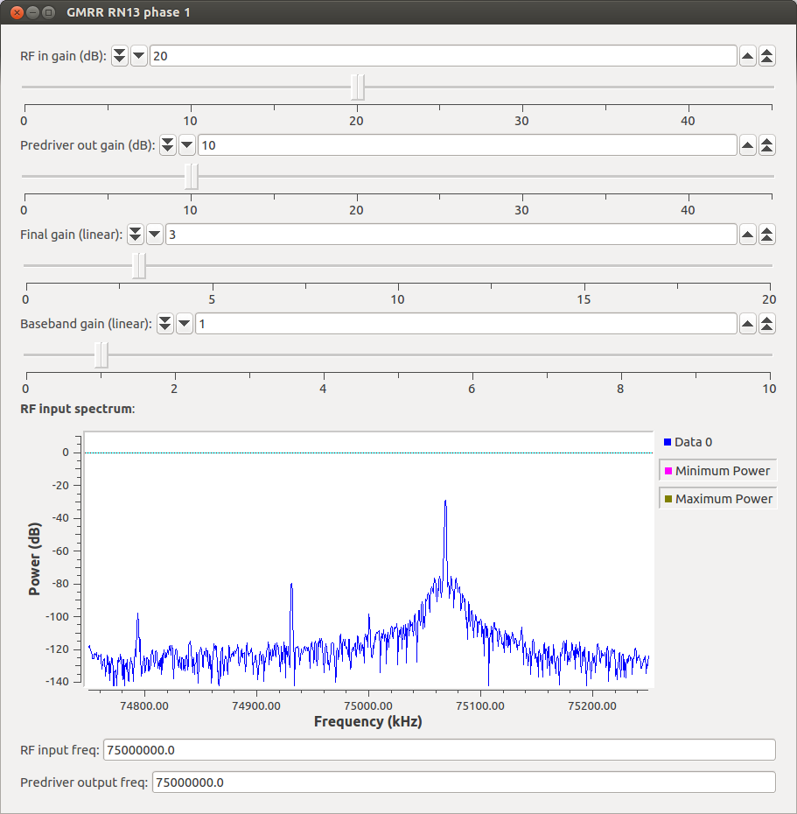
The spectrum display shows the received RF spectrum at the “RF” input of the GMRR USRP. The parameters are as follows:
- RF in gain (dB): This sets the gain of the RX2 input of the WBX. This gain in specified in dB.
- Predriver out gain (dB): This sets the gain of the TX output of the WBX. This gain is specified in dB.
- Final gain (linear): This sets the value of a digital gain multiplier on the “FINAL” output of the GMRR USRP's LFTX daughterboard, allowing control over the output envelope amplitude. This gain is specified as a linear value.
- Baseband gain (linear): This sets the value of a digital gain multiplier between the “RF” input and the “PREDRIVER” output of the GMRR USRP, allowing additional control over the “PREDRIVER” output level. This gain is specified as a linear value.
- RF input freq: This sets the GMRR USRP input frequency for the “RF” input port. This value is set in Hz.
- Predriver output freq: This sets the GMRR USRP output frequency for the “PREDRIVER” output. This value is set in Hz.
3. Update instructions
This step should only be performed if Corgan Enterprises has informed GMRR of updates to the project. To update the gmrr_rn13 project to the latest release, open a terminal and enter the following commands:
gmrr@Bonobo:~$ cd gr-gmrr_rn13
gmrr@Bonobo:~/gr-gmrr_rn13$ git remote update
gmrr@Bonobo:~/gr-gmrr_rn13$ git pull
gmrr@Bonobo:~/gr-gmrr_rn13$ cd build
gmrr@Bonobo:~/gr-gmrr_rn13$ make
gmrr@Bonobo:~/gr-gmrr_rn13$ sudo make install

Enter user gmrr's password when prompted.

4. Notes on Bonobo setup
PyBombs (http://github.com/pybombs) was used to install Gnuradio. Because of a few peculiarities of the Bonobo setup, some additional pre-build setup was required:
- Package zlib1g-dev was installed to provide ZLib headers.
- Ubuntu's update-alternatives system was used to select Python 2.7 as the default – both Python 2.6 and 2.7 are installed on Bonobo, with Python 2.6 as the default. Python 2.7 was selected because on Bonobo, external Python packages (numpy, cheetah, etc.) had been installed to Python 2.7. To change the default back to Python 2.6 (should not be necessary), use:
$ sudo update-alternatives –config python
- An SSH key was generated and placed in ~/.ssh/id_rsa. The corresponding public key, ~/.ssh/id_rsa.pub, was uploaded to Github and added to the deployment keys list for this project in order to provide updates. The secret key appears nowhere other than on Bonobo.

